1/12/23
Dear Customer,

Mars Wrigley UK is taking the precautionary step of recalling a limited number of Revels® 205g Slimpouch, Revels® 112g Pouch and Revels® 71g Treat Bag (PMP) in the UK & Ireland with the specific best before date detailed below due to the potential presence of very small pieces of rubber.

IMAGE (for illustrative purposes only) | PRODUCT DESCRIPTION | PRODUCT ID CODE | BATCH CODE | BEST BEFORE DATE
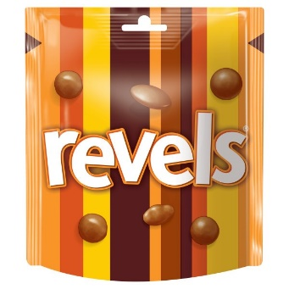 | Revels® 205g Slimpouch | CR42P | 344G2SLO00  345B1SLO00 | 27.10.202403.11.2024
 | Revels® 112g Pouch | CR15K | 344E1SLO00  344E2SLO00  344F1SLO00  344F2SLO00  345D2SLO00  345E1SLO00  345E2SLO00  345F2SLO00  345G1SLO00  346C1SLO00 | 27.10.2024 03.11.2024 10.11.2024
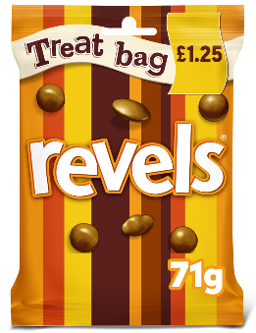 | Revels® 71g Treat Bag (price marked pack) | DF68P | 344G2SLO00 | 27.10.2024

While the risk to consumers is low, initial indications show that much of the affected product is likely to have been sold to consumers. We have proactively approached the Food Standards Agency for their guidance and in agreement with them, we are taking the precautionary measure of recalling a limited number of Revels®. We’re sincerely sorry for any inconvenience caused.

Please see uplift procedure below.

To help ensure that shoppers have easy access to the correct information, the in-store notice supplied (see other attachment) should be displayed at the Customer Care desk in the store. It details the product being recalled and how to contact the Mars Consumer Care line if they have questions.

We remain in close contact with the Food Standards Agency who are releasing a notice to consumers via their alert system soon.

We’re sincerely sorry for any inconvenience caused.

Yours sincerely,

Matt Boulter, Sales Director – Mars Wrigley UK

~

Annex - Uplift instructions

Direct Mars Customers
Please ensure that any stock of product with the details listed above that you still have in your control is removed from sale, isolated and placed on hold at store and depot level.
PLEASE DO NOT DESTROY OR DISPOSE OF THE PRODUCTS.

Please confirm that the hold has been placed and the volume that you have in your control to your Mars Customer Service contact.
To help ensure the most efficient process, we ask that our customers bring back affected stock from stores to your central depots.
In the meantime, our Customer Service team will be in touch to arrange uplift from your depots as soon as possible through our hauliers.
Please be aware if you are a distributor of Mars product, your customers will be asked to follow the below instructions, bringing affected stock to you. Multiple collections can therefore be arranged.

For all Indirect Mars customers
Please return affected product to your supplier who will then follow the above process; returning affected stock back to central depots.
If you have questions regarding this process, please get in touch with your Mars Customer Supply Chain contact.
We are doing our utmost to minimise disruption and we thank you for your patience and co-operation.

