MCURC - The Business Case for Plant-Forward ProcurementMCURC - The Business Case for Plant-Forward Procurement

The Business Case for Plant-Forward Procurement
Analysis from the Menus of Change
University Research Collaborative's
Collective Impact Initiative
1

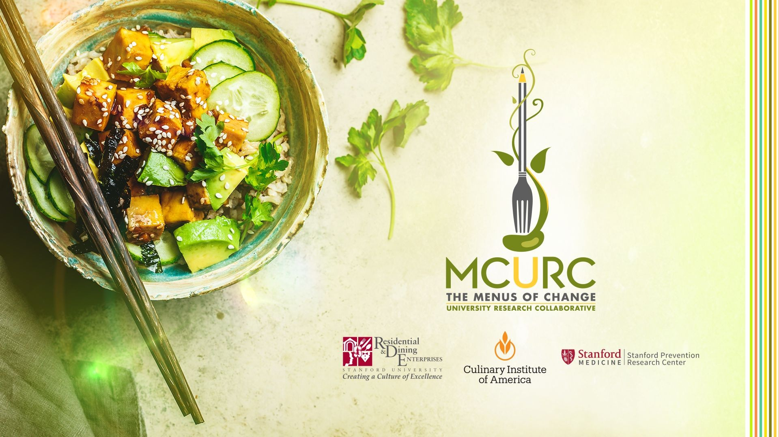


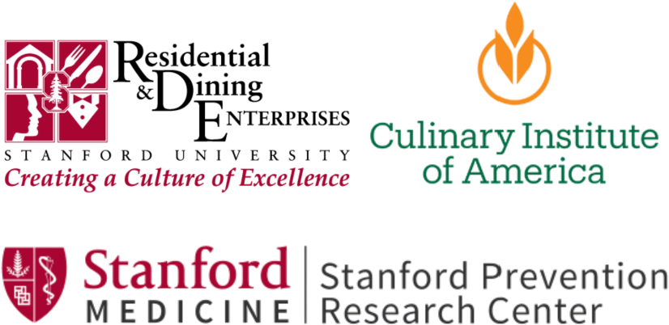

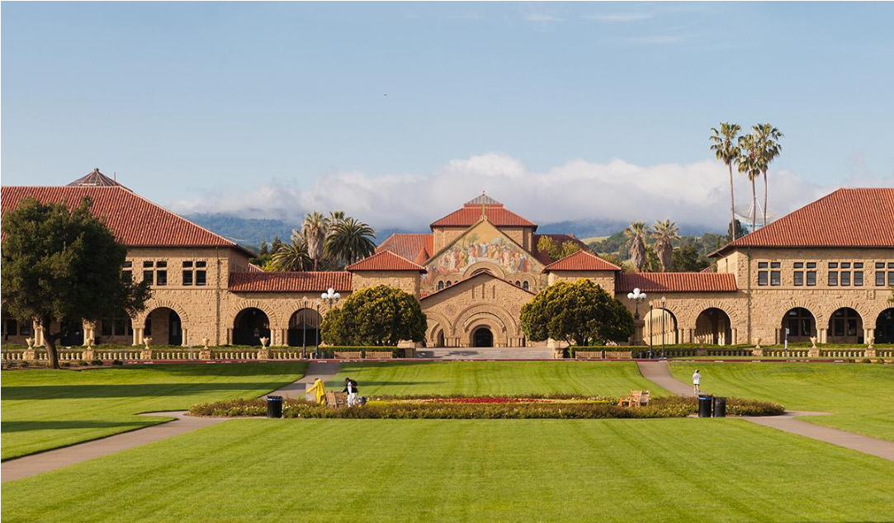
The Menus of Change University Research
Collaborative
Founded in 2014




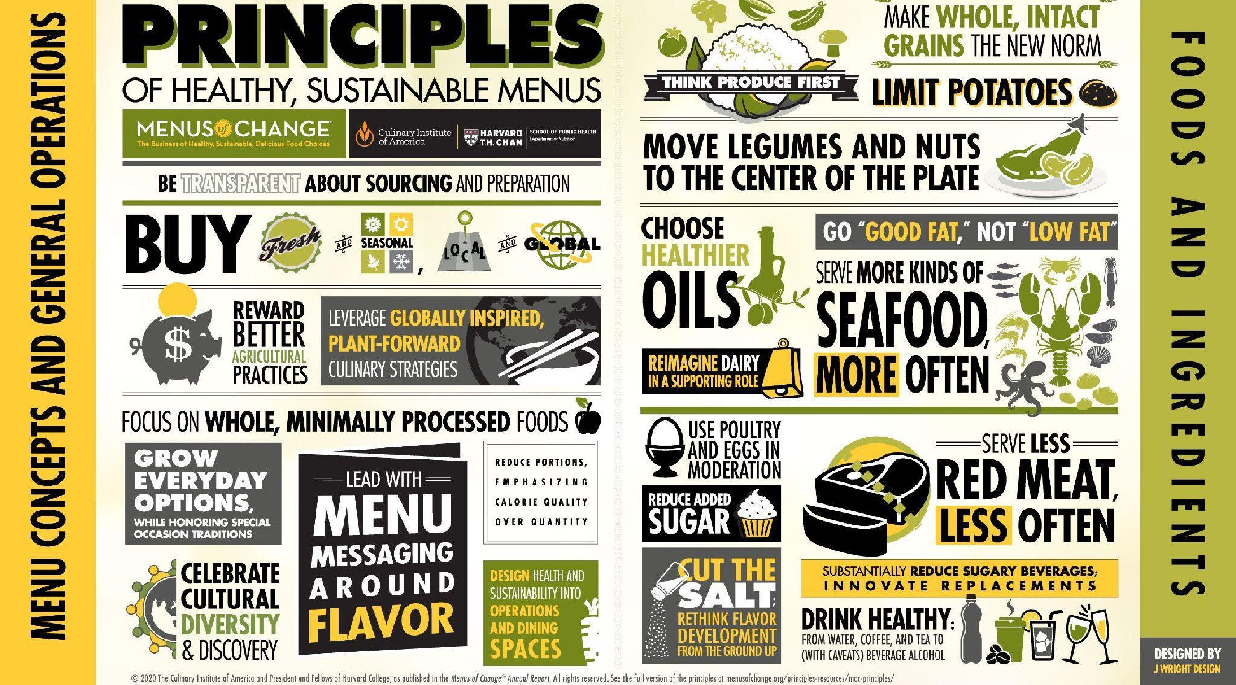


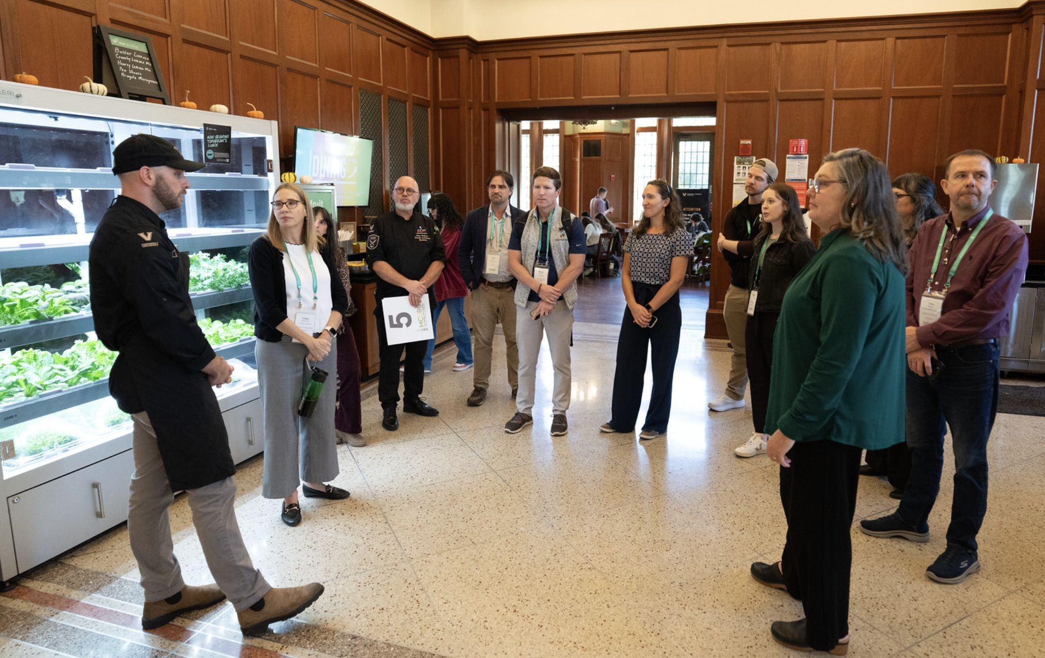
Cultivating the long-term well-being of all people and the
planet — one student, one meal at a time.

Our Mission
The Menus of Change University Research Collaborative
(MCURC)—co-founded and led by The Culinary Institute of America, Stanford Residential & Dining Enterprises,
and Stanford Prevention Research Center— is a global

network of over 85 colleges and universities accelerating progress toward healthier, more sustainable, and
delicious food choices using evidence-based research, education, and innovation.


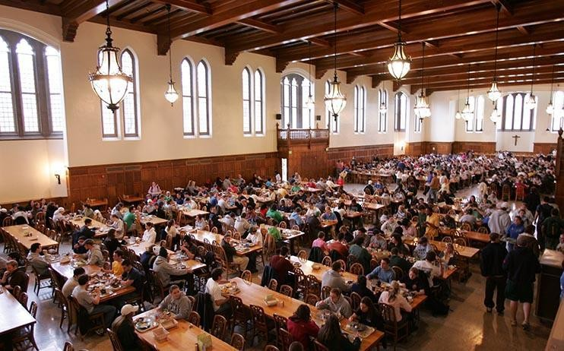

Leaders
Entrepreneurs
Consumers
Parents
Tomorrow’s
meals served
every day
4
million
meals during
their lifetime
70
billion
Students are the best way forward

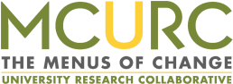

Senior University
Administrators
Academics
Executive Chefs
Nutrition &
Sustainability
Managers
Dining Directors
Student Fellows
For the first time, collaborating together
Accelerating
innovation
Advancing
MOC
principles
Pioneering
research
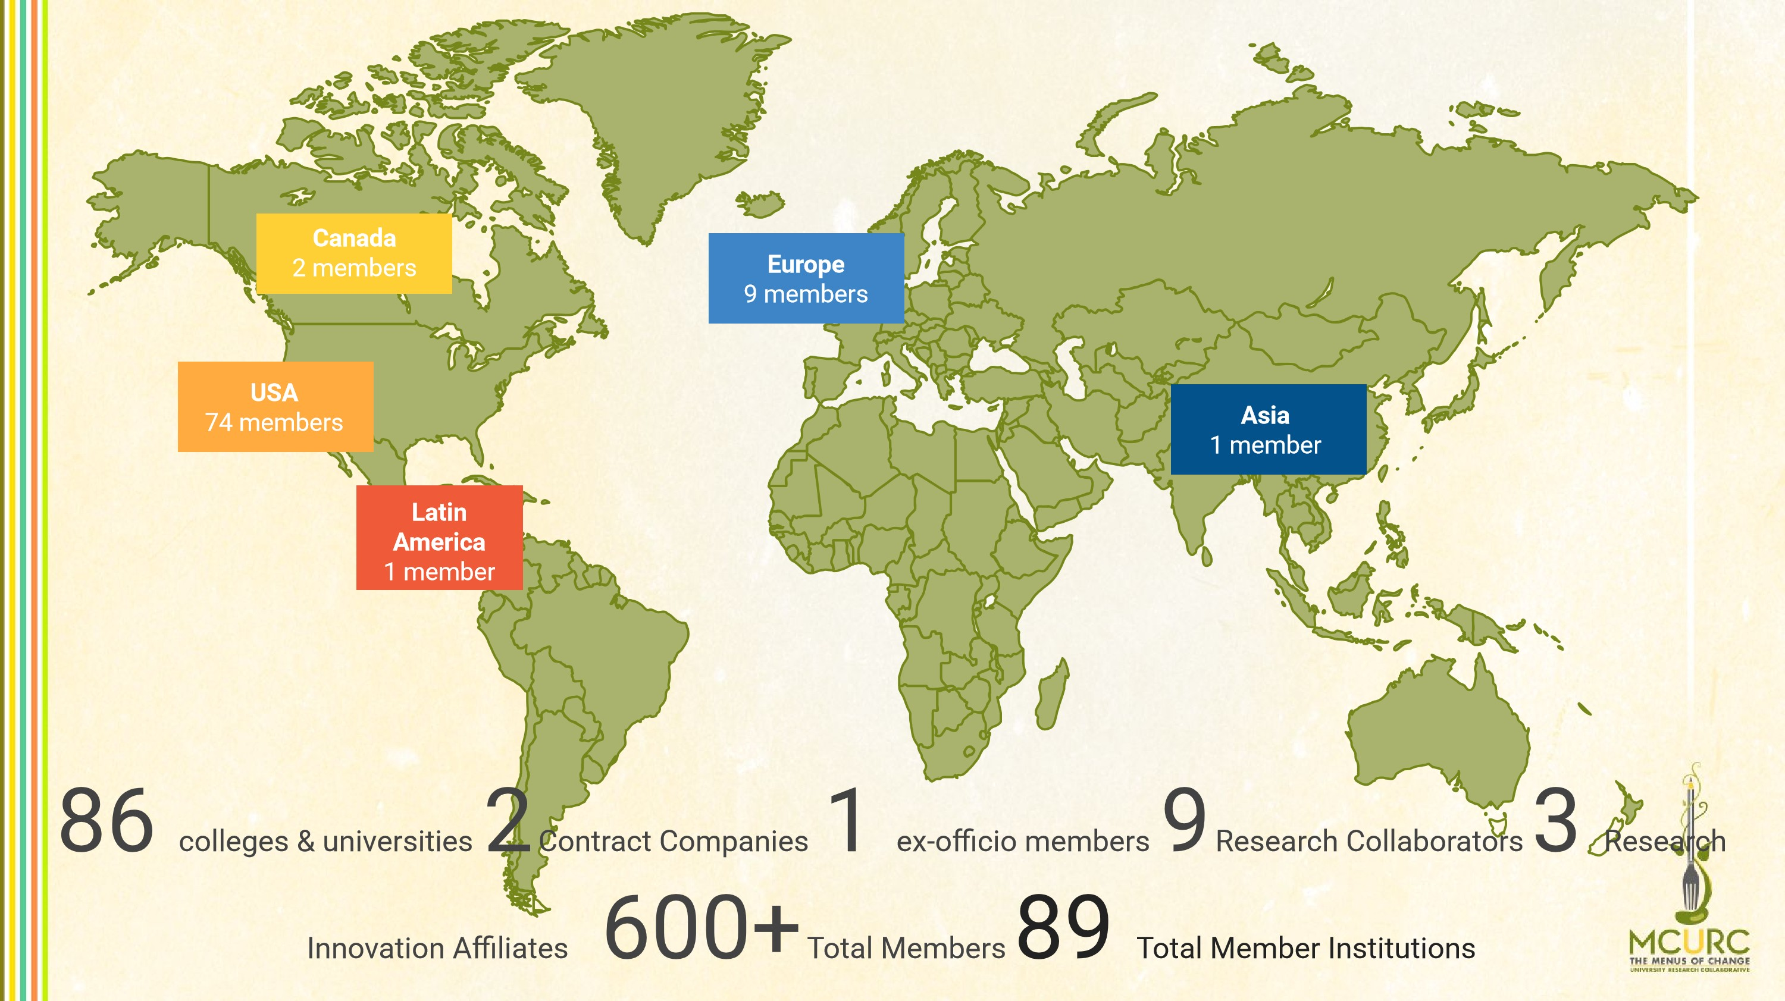


Extensive and Inclusive Membership

Arizona State University
Boston College
Boston University
Central Washington University
Centre for Alternative Technology
Claremont Graduate University
College of the Holy Cross
Colorado State University
Columbia University
Cornell University
The Culinary Institute of America
Duke University
Drexel University
Georgia College & State University
Georgetown University
George Washington University
Harvard University
Hotel Management School (Maastricht)
INSEAD (France)
Johns Hopkins University
Kansas State University
King’s College University
Marist University
Massachusetts Institute of Technology
Michigan State University
New York University
Northeastern University
North Carolina Central University
North Carolina State University
Occidental College
The Ohio State University
Ohio University
Oregon State University
Paul Bocuse Institute (France)
Penn State
Penn State-Lehigh Valley
Pomona College
Princeton University
Singapore Institute of Technology
Queens College
Rice University

Rutgers University
Sacramento State University
San Jose State University
Stanford University
The Culinary Institute of America
Tufts University
University of Arkansas
Universidad Anáhuac Mayab, Mexico
University of Barcelona (Spain)
University of Bristol (UK)
University of British Columbia (CA)
University of California, Berkeley
University of California, Davis
University of California, Los Angeles
University of California, Merced University of California, Office of the President University of Montana
University of California, Riverside University of New Hampshire
University of California, San Diego University of North Texas
University of California, San Francisco University of Notre Dame
University of California, Santa Barbara University of Reading (UK)

University of Colorado, Boulder University of Southern California
University of Connecticut University of Texas, Austin
University of Guelph (CA) University of Vermont
University of Iowa University of Warsaw (PO)
University of Kansas University of Washington
University of Maryland Vanderbilt University
University of Massachusetts, Amherst University of Villanova
University of Massachusetts, Lowell Virginia Tech
University of Michigan Yavapai College
University of Missouri

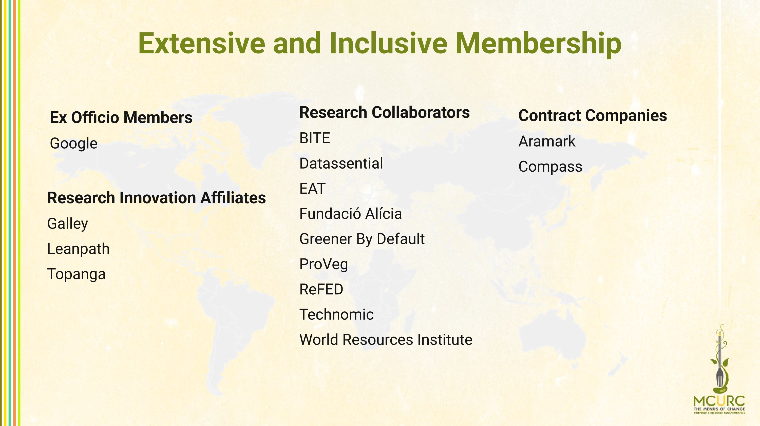



MCURC Founding Sponsors
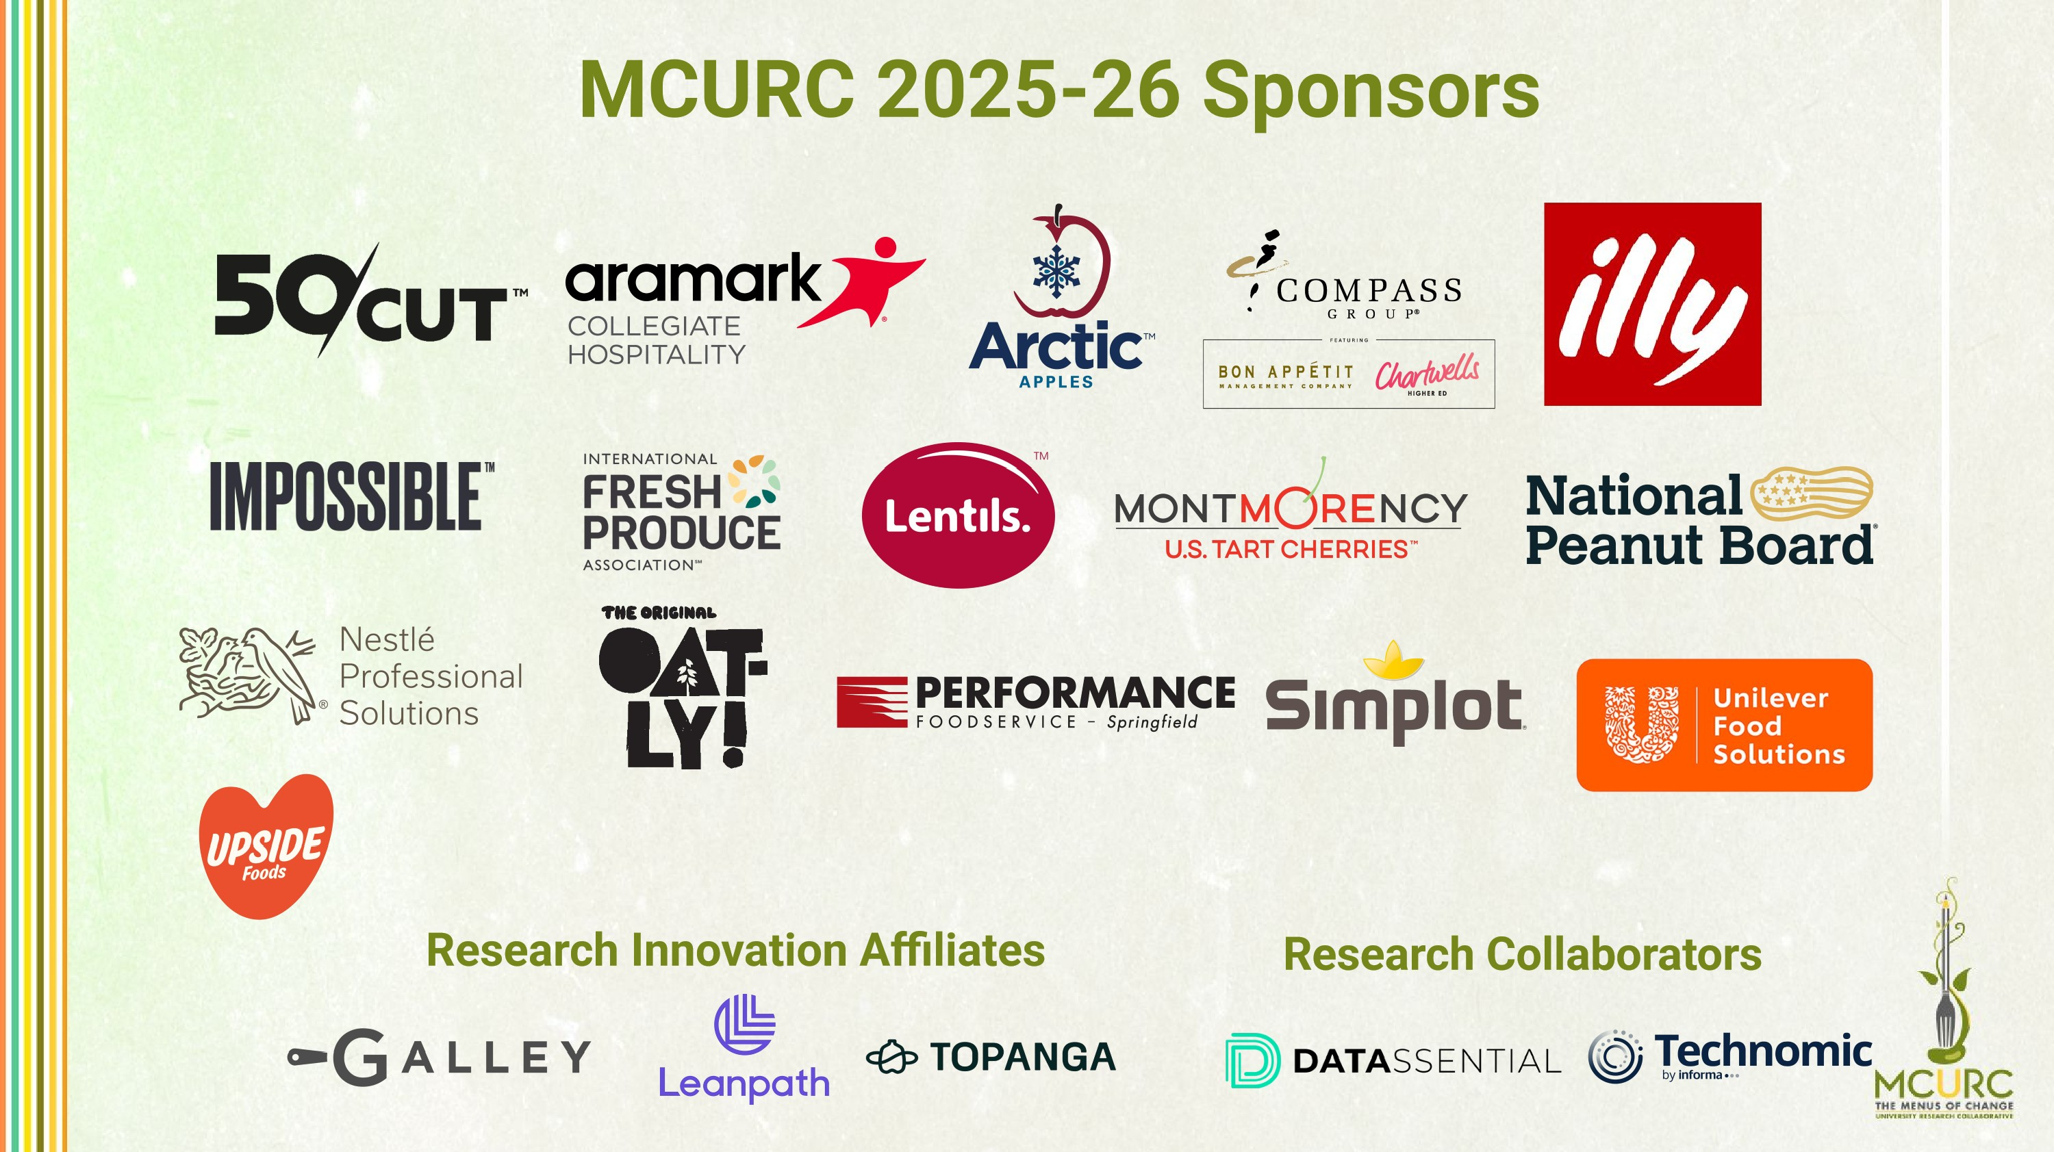
Develop Scalable, Applied Solutions to Promote Healthy, Sustainable, and Delicious Food Choices
And Delicious Food Choices
Identify and evaluate the culinary
processes to develop delicious
recipes
4
To Promote Healthy, Sustainable
Keep in sight that the endgame
deliverable is not only research, but impact
on students’ actual diets
3
Applied Solutions
Focus on practical
guidelines and teamwork
to ensure operational
feasibility
2
Scalable
Deliver research outcomes
and methodologies based on
scaled initiatives
1
Academic Research
Develop an academic research
portfolio to have broadly
generalizable research published in
peer-reviewed journal
Operational Research
Develop process improvement
interventions that will allow the
improvement of dining operations
Collective Impact Projects
Develop a culture of sharing data on
purchasing of specific foods that are at
the center of the MOC principles
MCURC Research: Shifting Diets
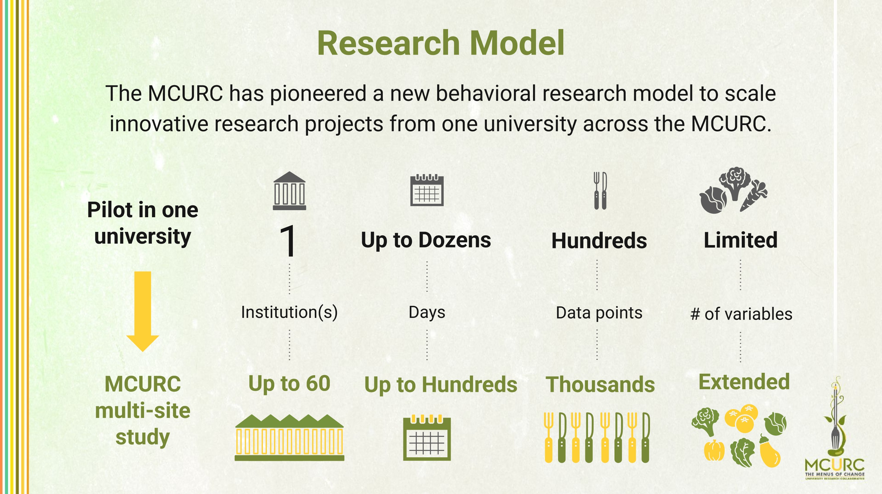



Most effectively
produce, promote,
and upcycle food
to reduce waste
Food Waste
Reduction
The MCURC Research Agenda
Transform protein
menu concepts,
including the Protein
Flip, and elevating
plant-based protein
Plant-Forward
Promotion
Evaluate how
education can induce
healthier and more
sustainable food
choices
.
Increased Food
Literacy
MCURC Published Research Projects
Find all published academic projects here
Previous projects found on the website.
- - Multi-Site Research Project) Effects of Taste-Focused vs. Health-Focused Labels on Vegetable Selection and Consumption in University Dining Halls: A Randomized Controlled Multi-Site Intervention. Study published in Psychological Science.
- - Multi-Site Research Project) Faith in Fat: A Multisite Examination of University Students’ Perceptions of Fat in the Diet. Study published in Nutrients.
- - Multi-Site Research Project) Impact of a Scalable, Multi-Campus “Foodprint” Seminar on College Students’ Dietary Intake and Dietary Carbon Footprint. Study published in Nutrients.
- - Multi-Site Research Project) Food Choice and Waste in University Dining Commons – A Menus of Change University Research Collaborative Study. Study Published in Foods.
- - Multi-Site Research Project) Food Waste Management Practices and Barriers to Progress in U.S. University Foodservice. Study Published in International Journal of Environmental Research and Public Health.
(2024 - Multi-Site Research Project) Evaluating Food Procurement against the EAT-Lancet Planetary Health Diet in a Sample of U.S.
Universities
Study Published in Interational Journal of Environmental Research and Public Health.
(2026 - Multi-Site Research Project) Plant-Based vs. Omnivore diets for athletic performance outcomes among recreational athletes in university dining halls: a randomized crossover study. Study published in Nutrition Journal.
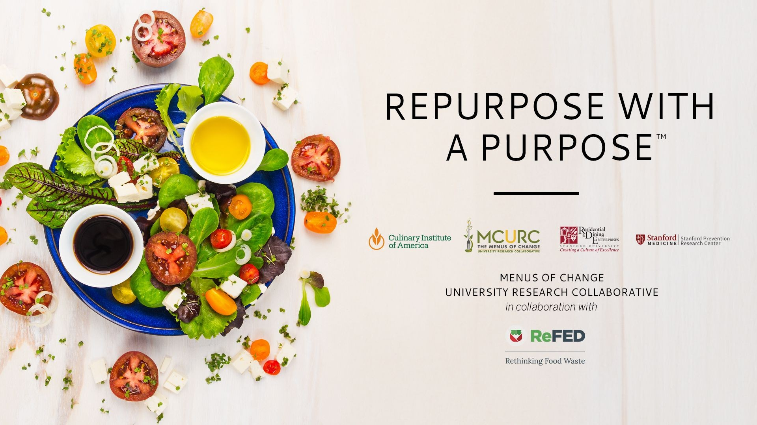
Multi-site Project Example





Measurable Outcomes
Food Waste
Reduction
Environment
al Impact
Cost
Savings
Social
Impact
Quantify
pre-consumer
food waste
Carbon
and water
savings
Reduced food
purchasing
Waste disposal
costs
Labor
Staff
engagement and
morale
Customer
satisfaction
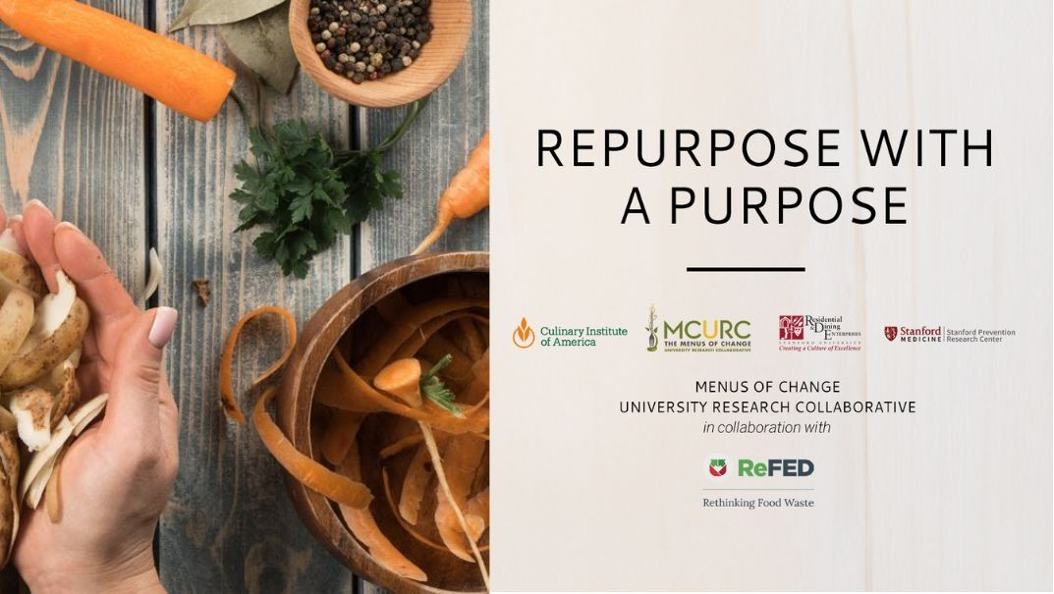
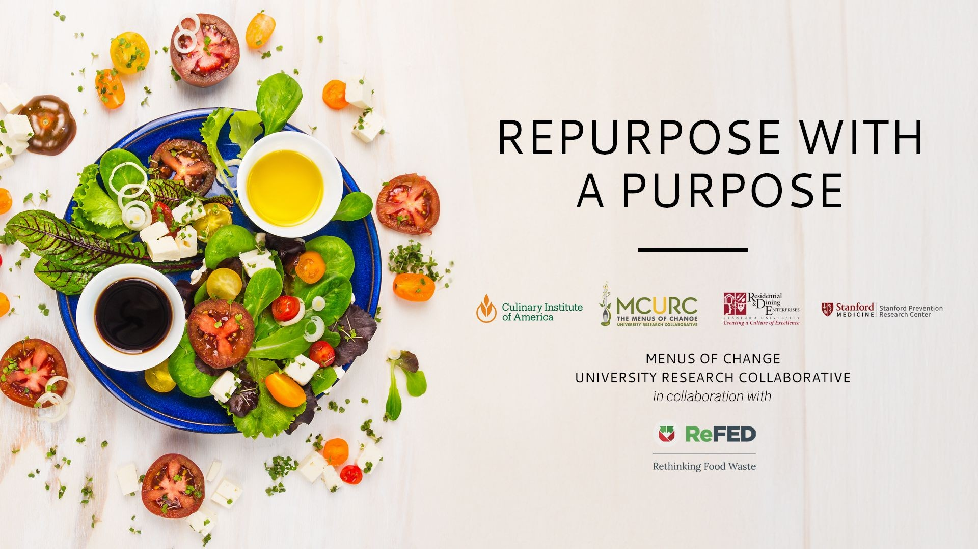
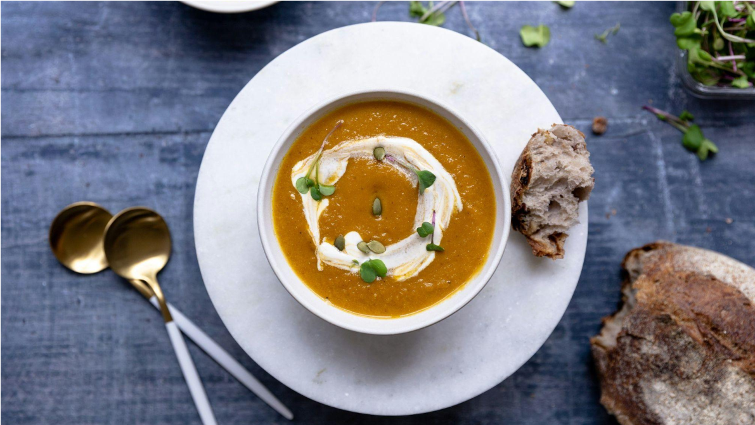
REPORT
OPERATIONAL TOOLKIT
PROJECT RESOURCES
RECIPE COLLECTION
Check them out on the

MCURC Resources Page


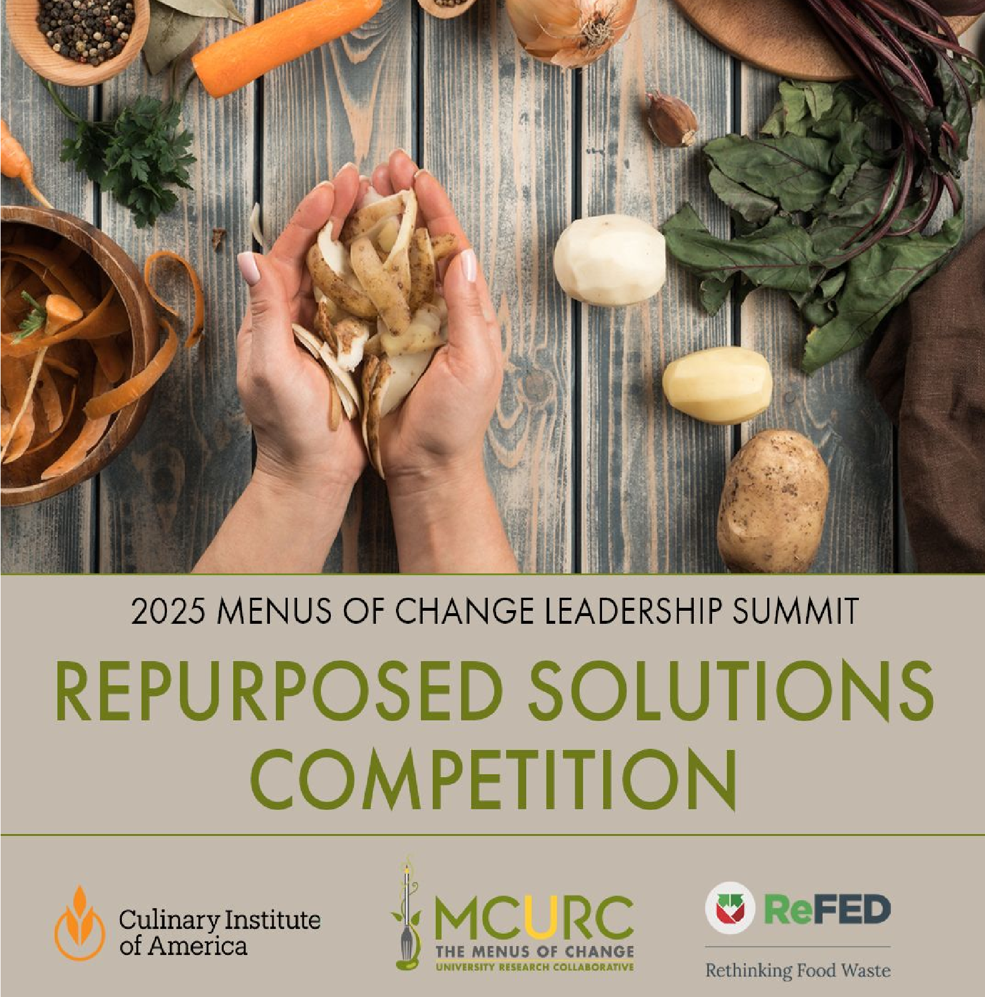
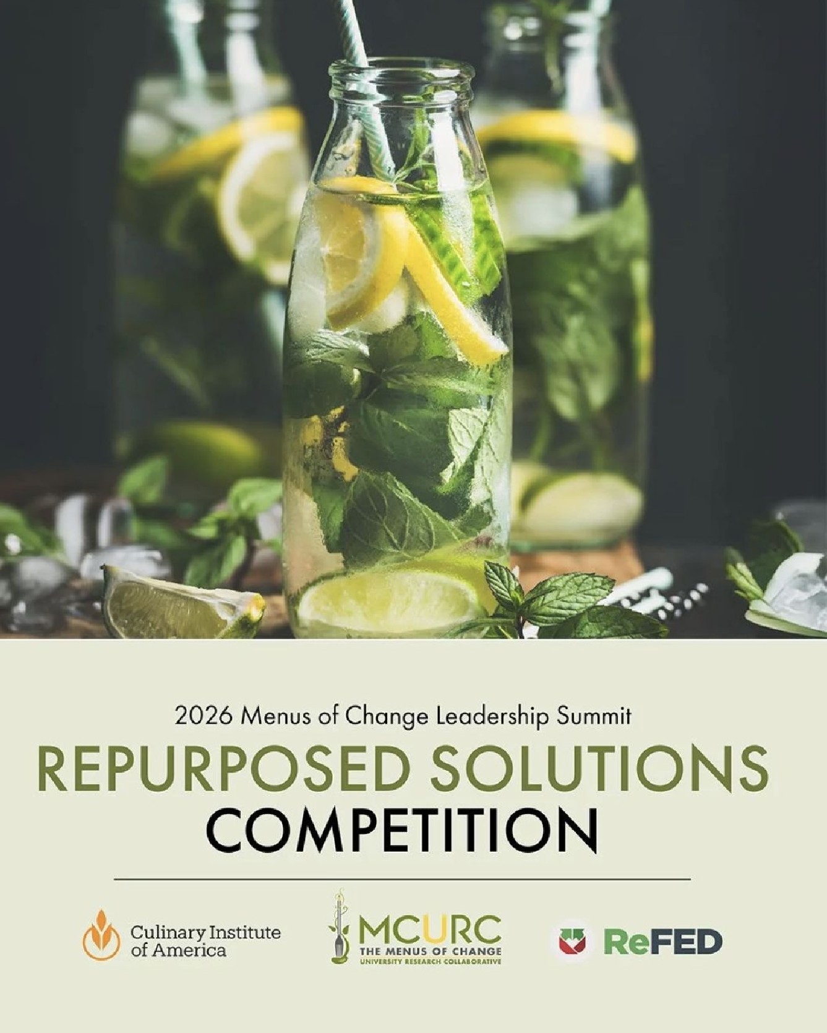


Current Research Pipeline

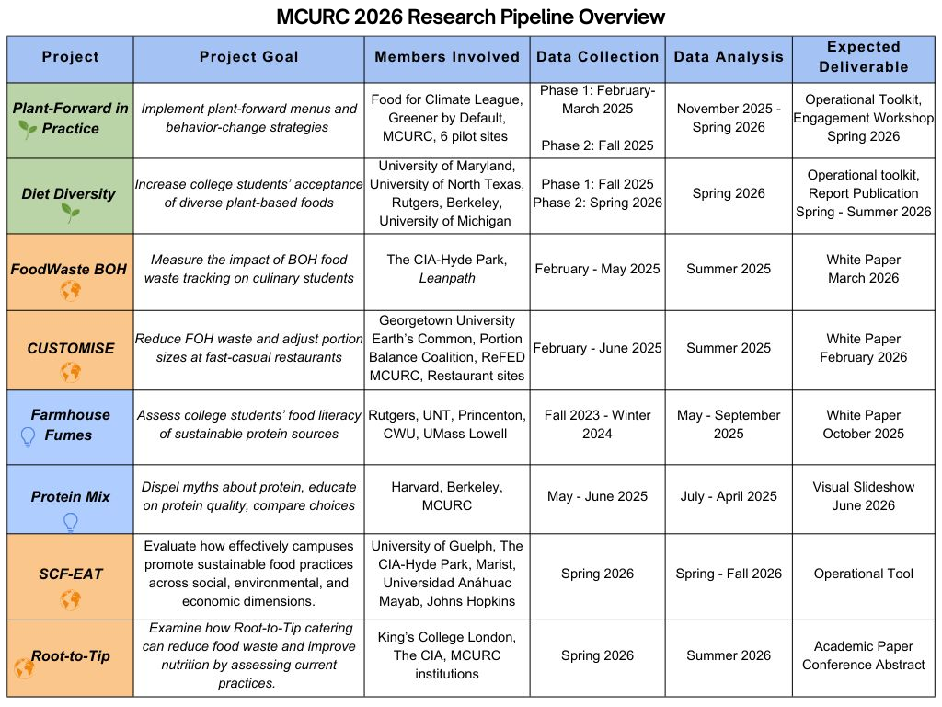
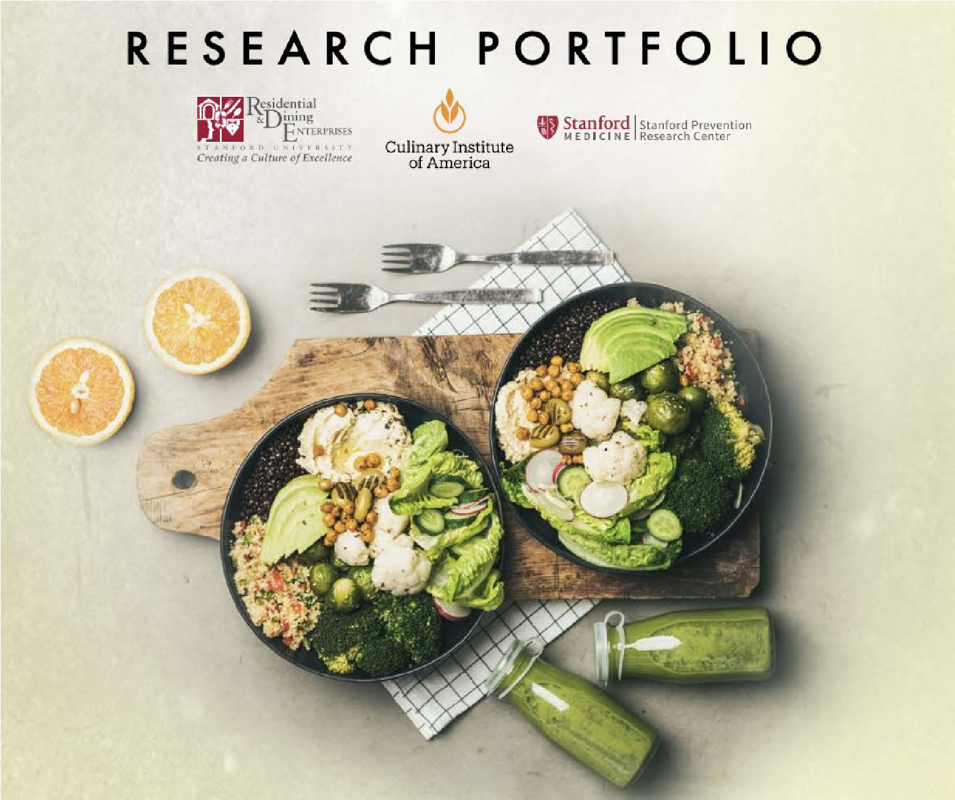


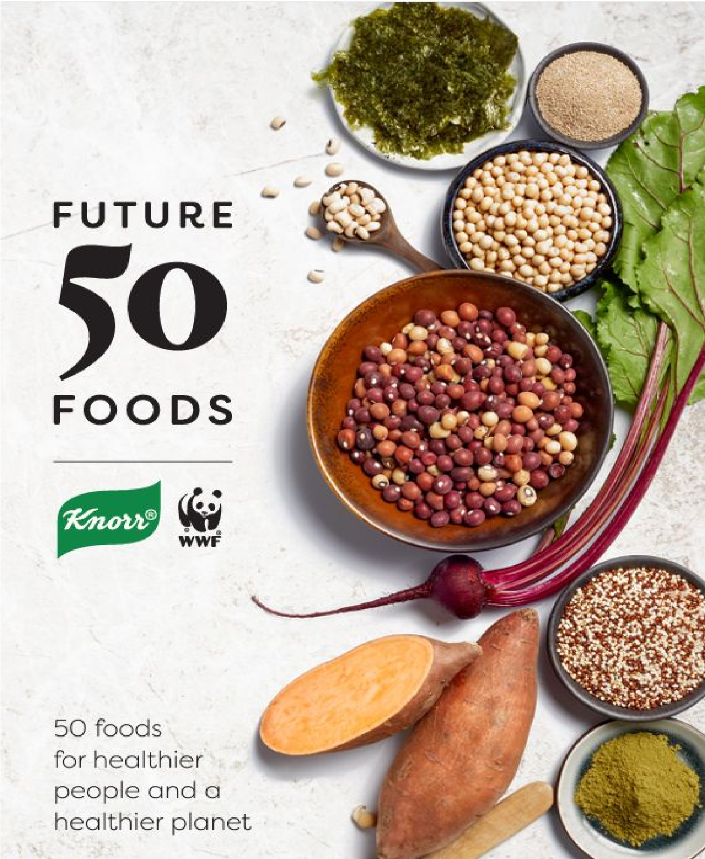

Diet Diversity Research Project
Study Purpose
Uncover opportunities and test
interventions that
increase
college
students’ knowledge and
acceptance
of diverse plant-based foods
, to
improve diet quality
as a key outcome
of greater dietary diversity.
Photo: Knorr & WWF. (2019) Future 50
Foods Report.

The MCURC Student Fellows Program
Program Overview (2026)
● A cohort of ~30
students
- 15 partner
institutions
- 8 states
- 3 countries
- 2 co-managers
- Consists of undergraduate and graduate students from MCURC member institutions
- Gives them the opportunity to gain experience conducting research that advances healthy, sustainable, delicious food choices in college and university settings
- Offers networking opportunities with the larger MCURC network across the country and around the world
- Student Fellows act as a bridge between a member university campus and the MCURC

2026
MCURC Annual All-Member Meeting
October 6th-7th (pre-meeting tour 10/5)

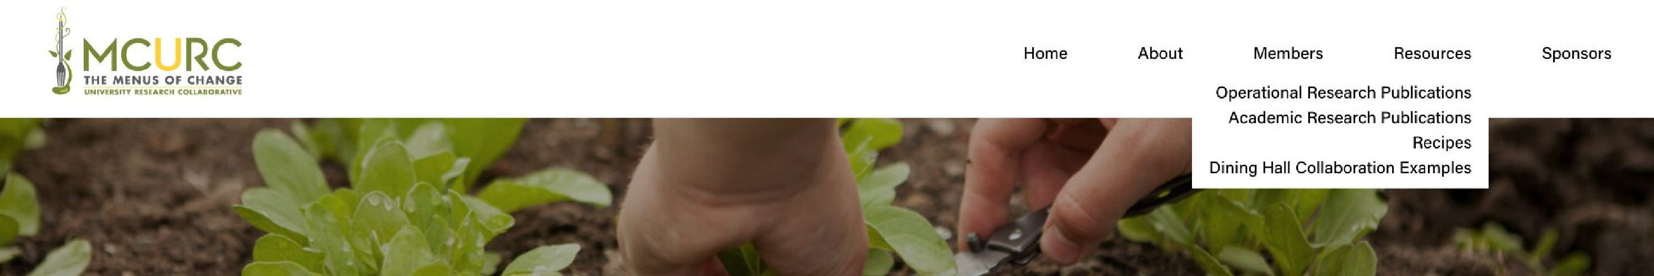
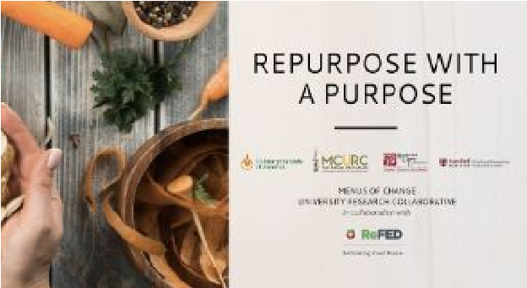
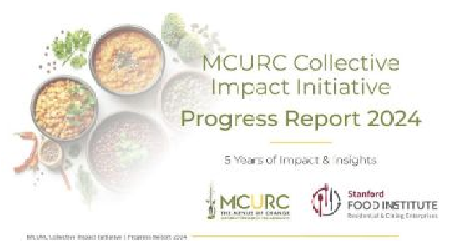
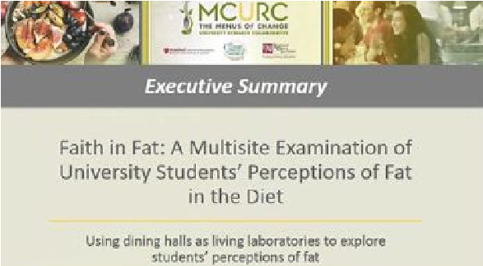

Menus of Change
Principles Resources
Faith in Fat, Olive Oil &
Plant-Forward Kitchen,
MOC Principles
Implementation
Plant-Forward Diet
Promotion
Collective Impact
Report, Plan-Forward
Opportunity Report,
Protein Flip Strategies
Related Website
Resources
Edgy Veggies Toolkit,
Training for Food System
Transformation
Cutting-Edge Resources for Operational and Academic Research Publications, Recipes and Dining
Hall Collaboration Examples - Available to Anyone, on our Website
Food Waste
Reduction
Repurpose with a Purpose
Operational Toolkit, Report
and Digital Recipe
Collection

Contact Us
Rachel Hoover
Director of Corporate Relations
The Culinary Institute of America
rachel.hoover@culinary.edu
Sponsorship opportunities
Sophie Egan
Co-Director
MCURC
Stanford University
smegan@stanford.edu
Abby Fammartino
Co-Director
MCURC
The Culinary Institute of America
abby.fammartino@culinary.edu
General inquiries
Valentina Córdoba
Research and Community Manager
MCURC
The Culinary Institute of America
valentina.cordoba@culinary.edu
SeaAnna Savage
Manager of Sponsorship Planning
The Culinary Institute of America
seaanna.savage@culinary.edu

